1)a) Insertion sort algorithm:

for j=2 to arr.length

key = arr[j]

i = j – 1

while(i>0 and arr[i]>=key)

arr[i+1]=arr[i]

i=i-1

arr[i+1]=key

1)b) T(n) = c1(n^2) + c2(n) + c3

1)c) Time complexity of the Insertion sort algorithm:

Best case time complexity: Ω(n)

Average case time compleity: Θ(n^2)

Worst case scenario: O(n^2)

2) Insertion sort code:

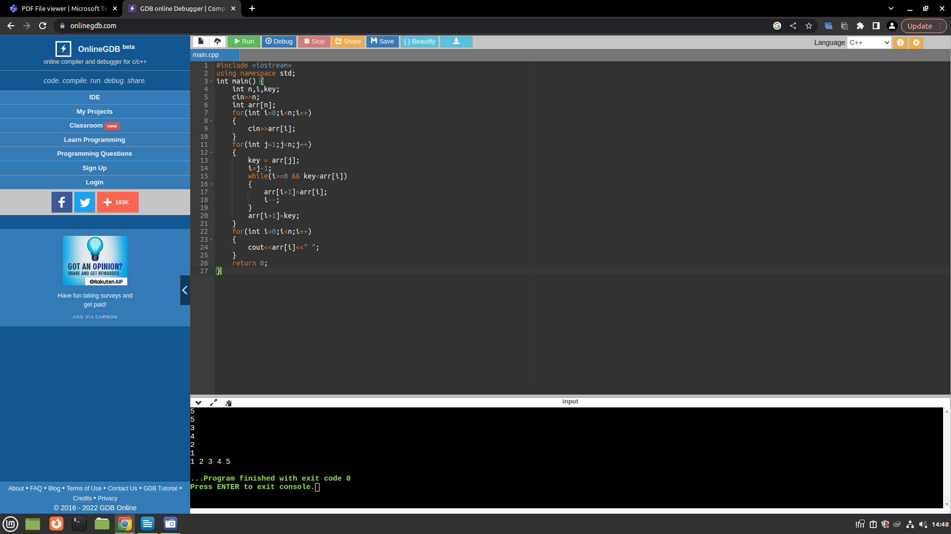

2)b) Finding the position of the element (Way-1):

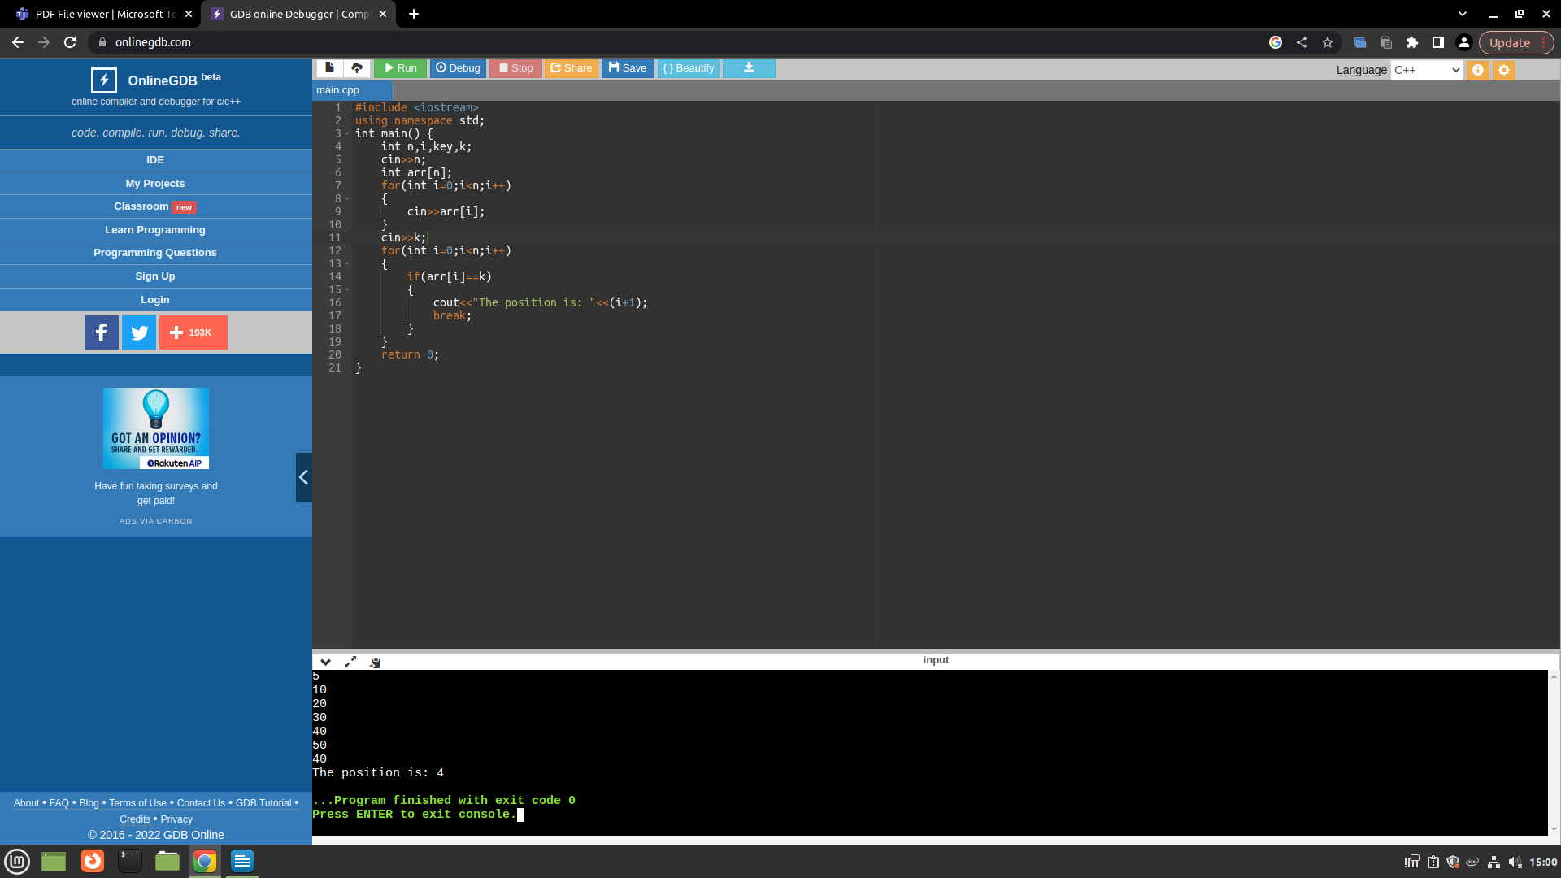

2)c) Finding the position of the element (Way-2):

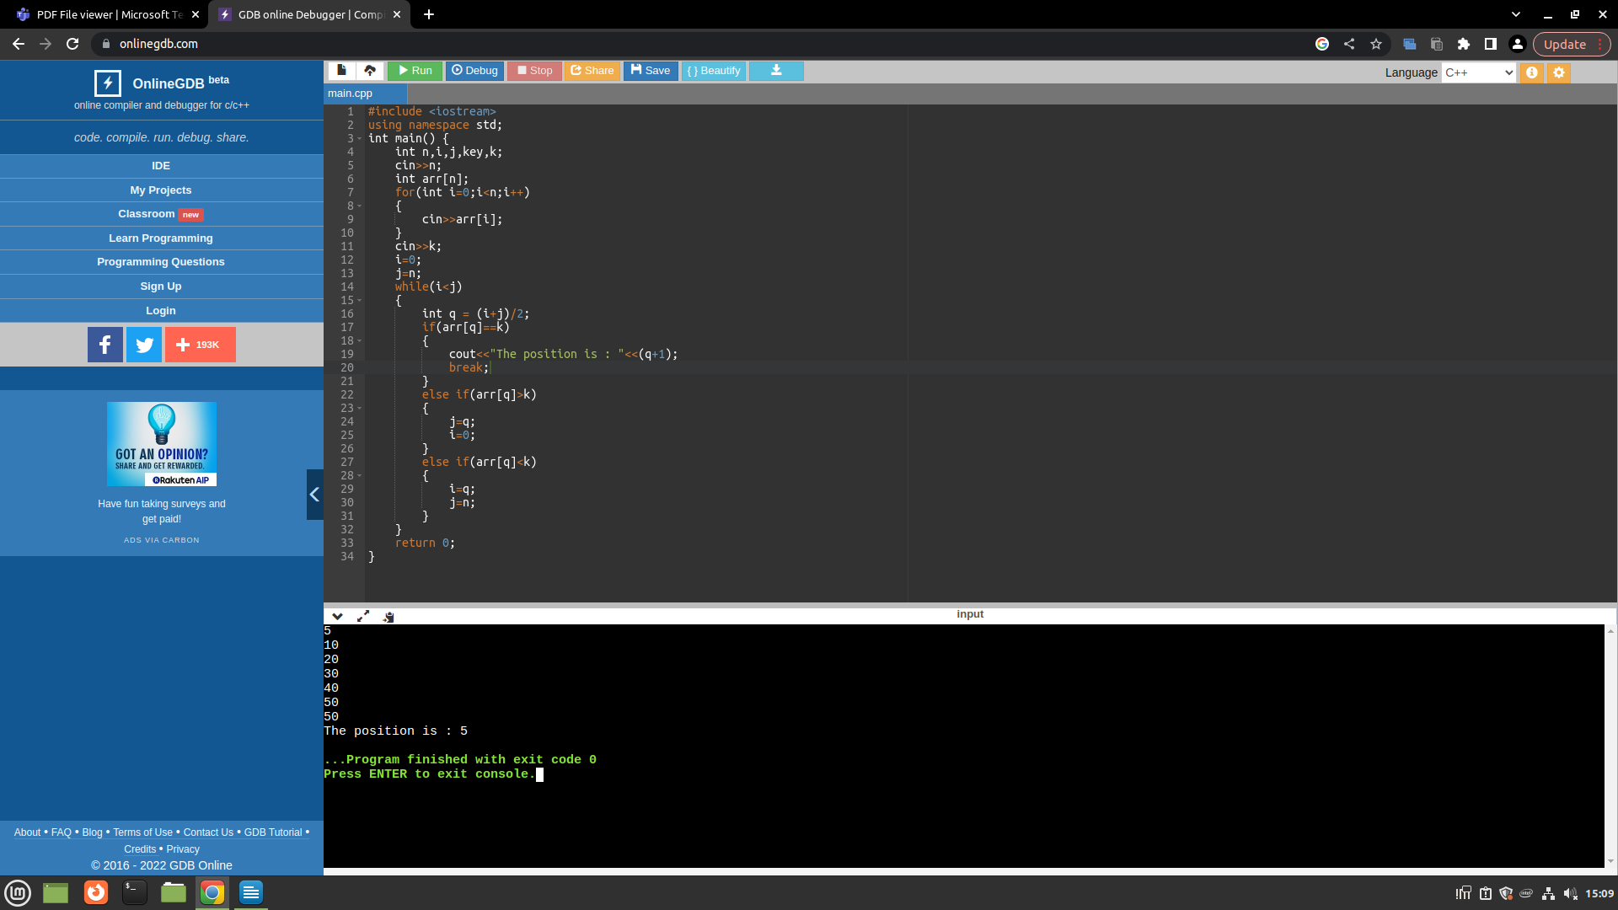

2)d)

